ARTIFICIAL INTELLIGENCE IN EVERY DAY LIFE

VOCABULARY

We can change the form of a word (e.g. from a verb to a noun) by adding suffixes. Use the words given in capitals at the end of sentences and the suffixes below to make new words and fill in thegaps.

Many times researchers study some areas to satisfy their curiosity but as a result new
things are invented. CURIOUS

Recent developments in machine learning has allowed us to create machines that can win
with humans in some areas. DEVELOP

Engineers can now apply advanced technological solutions to automatize many tasks
that required human input. ADVANCE

Machines are not always reliable and sometimes break down so we should limit how
much we depend on them in every day life. RELY

There are numerous reasons why we should create artificial intelligence. NUMBER

Some people believe that AI is such a transformable technology that it will change our lives
just as the Internet or TV did TRANSFORM

The invention of gunpowder was one of the most significant achievements of the Middle
Ages in China. INVENT

Their discovery was quickly confirmed, making it the first confirmation of planets outside
our Solar System DISCOVER

VIDEO AND DISCUSSION

Watch a video [https://youtu.be/mJeNghZXtMo] about AI (up to 3:51) and write down the answers to thesequestions:

  - What does the AI field of science deal with?

AI is a broad area of computer science that makes machines seem like they have uman intelligence. For example it’s when a program, which is programmed to do things like driving a car, learns to exhibit signs of human-like road rage.
  - When was the term “artificial intelligence”invented?
This technology isn’t new. Actually, for the past half-a-century, it’s been an idea ahead of its time. In fact the term “artificial intelligence” was first coined back in 1956 by Darmouth professor John McCarthy.

c) What are the factors responsible for the growth of AI in the recent years?
During the past few years, a couple of factors have led to AI becoming the next “big” thing.
First, huge amount of data are being created every minute. In fact, 90% of the world’s data has been generated in the past two years.
Now thanking to advances in processing speeds, computers can actually make sense of all this information more quickly.

d) How is AI being used now?
Now AI is used in many different shapes and types:
First we have bots, they’re text-based and incredibly powerful, but they have some limitations, like confusion on complex requests given to it.
Another example of bots is the vocal assistant, like Siri or Cortana, which translates your voice into text and read the answer back in human syntax, so you don’t have to speak in code.
A machine like IBM’s Watson can diagnose cancer, compose classical symphonies or crush Ken Jennings at Jeopardy.
Some programs even mimic the way the human brain is structured, complete with neural networks that help humans, and now machines, solve problems.

Select the right option in the sentences below, then watch the video again to chec
your answers:

  - AI is designed so you don't realize there's a computer calling/firing the shots.
  - The term "artificial intelligence" was first crafted/coined by Dartmouth professor John McCarthy.
  - And now thanks to advances/advantages in processing speeds, computers can actually make sense of all this information more quickly.
  - Tech giants and venture/visiting capitalists have bought into AI and are infusing the market with cash and new applications
  - That means AI can manifest itself in many different ways. Let's break/take down the options.
  - Natural language processing makes these bots a bit more shallow/sophisticated.

Record your personal contribution to the topic. Use the following questions to organize your speech:

- How does Artificial Intelligence impact our life today?
- How could the artificial intelligence technology be used in the future?
- What are the key advantages of this technology in your opinion?
- What aspects of AI can make it dangerous?

Watch a video from Google I/O conference 2018 [https://youtu.be/D5VN56jQMWM] and consider these points:
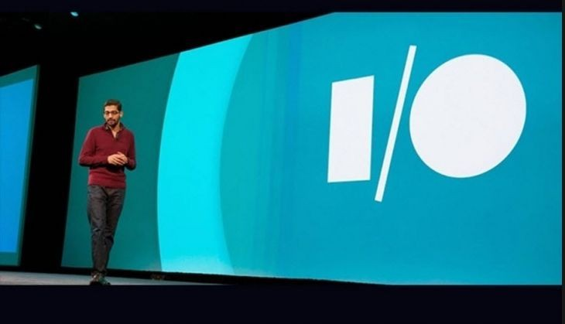
  - What’s your opinion of this use of AI technology?
  - Which aspect of this technology do you find most surprising?
  - Would you be willing to use it yourself? Why/Why not?

Get ready to discuss about that in Meet on Saturday 16th.

Interesting resource suggested by your FCE classmate Gusella: https://www.youtube.com/watch?v=I-EIVlHvHRM (interesting topic and useful listening practice)

